
Department of Basic Engineering Sciences-1

DATA STRUCTURES USING PYTHON

I/IV-B.Tech-(II Sem), Academic Year: 2024-2025

Session-6 Quick Sort
Instructional Objective:
- To learn the concept ofsorting and sort an array using quick sort.
- To derive the time complexity of Quick sort.

Learning Outcomes:
- Students able to understand the quick sort
- Students able to analyze the time complexity of quick sort

1. Introduction:

- The quick sort algorithm starts by picking a pivot element and then subdivides the array. It then puts the smaller elements on the left side of the pivot and the larger ones on the right side. The partition of arrays continues until each array is left with a single element.
- Divide: In Divide, first pick a pivot element. After that, partition or rearrange the array into two sub-arrays such that each element in the left sub-array is less than or equal to the pivot element and each element in the right sub-array is larger than the pivot element.
- Conquer : Recursively, sort two sub arrays with Quick sort.
- Combine: Combine the already sorted array.
- Quick sort picks an element as pivot, and then it partitions the given array around the picked pivot element. In quick sort, a large array is divided into two arrays in which one holds values that are smaller than the specified value (Pivot), and another array holds the values that are greater than the pivot.
- After that, left and right sub-arrays are also partitioned using the same approach. It will continue until the single element remains in the sub-array.
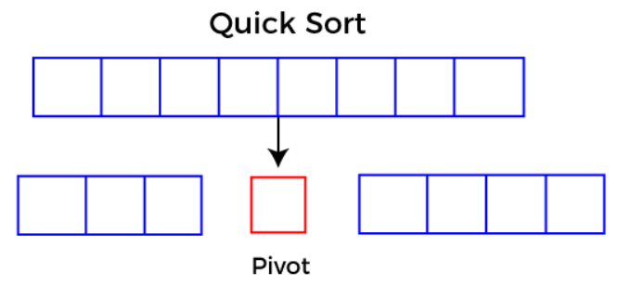

EXAMPLE OF QUICK SORT :
Working of Quick Sort Algorithm
Now, let's see the working of the Quicksort Algorithm.
To understand the working of quick sort, let's take an unsorted array. It will make the concept more clear and understandable.
Let the elements of array are –
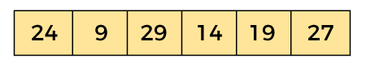
In the given array, we consider the leftmost element as pivot. So, in this case, a[left] = 24, a[right] = 27 and a[pivot] = 24. Since, pivot is at left, so algorithm starts from right and move towards left.
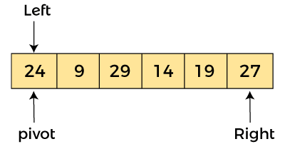

Now, a[pivot] < a[right], so algorithm moves forward one position towards left, i.e. -
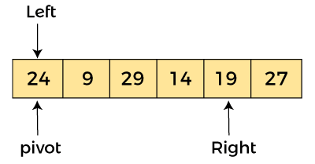
Now, a[left] = 24, a[right] = 19, and a[pivot] = 24.
Because, a[pivot] > a[right], so, algorithm will swap a[pivot] with a[right],
and pivot moves to right, as –
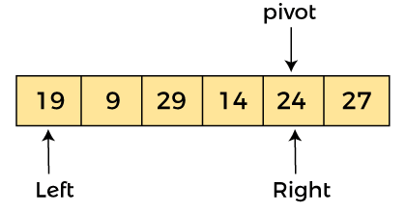

Now, a[left] = 19, a[right] = 24, and a[pivot] = 24. Since, pivot is at right, so algorithm starts from left and moves to right. As a[pivot] > a[left], so algorithm moves one position to right as -
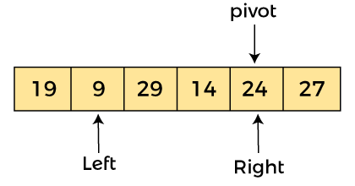
Now, a[left] = 9, a[right] = 24, and a[pivot] = 24. As a[pivot] > a[left], so algorithm moves one position to right as -

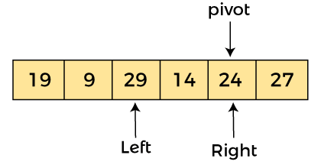
Now, a[left] = 29, a[right] = 24, and a[pivot] = 24. As a[pivot] < a[left], so, swap a[pivot] and a[left], now pivot is at left, i.e. -
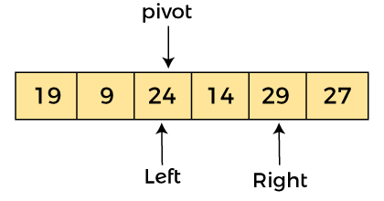
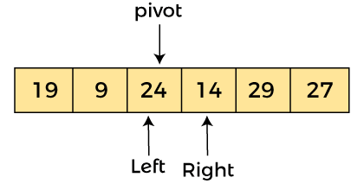
Now, a[pivot] = 24, a[left] = 24, and a[right] = 14. As a[pivot] > a[right], so, swap a[pivot] and a[right], now pivot is at right, i.e. -
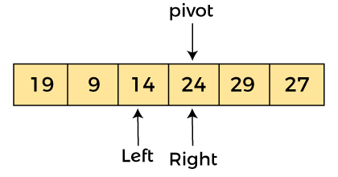
Now, a[pivot] = 24, a[left] = 14, and a[right] = 24. Pivot is at right, so the algorithm starts from left and move to right.
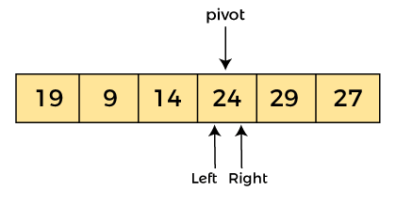
Now, a[pivot] = 24, a[left] = 24, and a[right] = 24. So, pivot, left and right are pointing the same element. It represents the termination of procedure.
Element 24, which is the pivot element is placed at its exact position.
Elements that are right side of element 24 are greater than it, and the elements that are left side of element 24 are smaller than it.

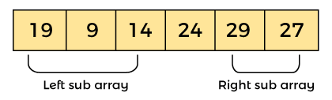

Now, in a similar manner, quick sort algorithm is separately applied to the left and right sub-arrays. After sorting gets done, the array will be -
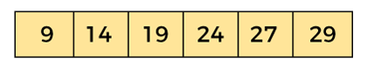
Implementation of Quick sort in descending order
def quick_sort(arr, low, high):
if low < high:
# Find the pivot element such that elements greater than pivot are on the left
pivot_index = partition(arr, low, high)
# Recursively sort the elements before and after partition
quick_sort(arr, low, pivot_index - 1) # Left of pivot
quick_sort(arr, pivot_index + 1, high) # Right of pivot
def partition(arr, low, high):
# Choose the last element as the pivot
pivot = arr[high]
# Pointer for the smaller element
i = low - 1
# Traverse through the array and arrange elements
for j in range(low, high):
if arr[j] > pivot: # Compare with pivot for descending order
i += 1
arr[i], arr[j] = arr[j], arr[i] # Swap if greater than pivot
def quick_sort(arr, low, high):
if low < high:
# Find the pivot element such that elements greater than pivot are on the left
pivot_index = partition(arr, low, high)
# Recursively sort the elements before and after partition
quick_sort(arr, low, pivot_index - 1) # Left of pivot
quick_sort(arr, pivot_index + 1, high) # Right of pivot
def partition(arr, low, high):
# Choose the last element as the pivot
pivot = arr[high]

# Pointer for the smaller element
i = low - 1

# Traverse through the array and arrange elements
for j in range(low, high):
if arr[j] > pivot: # Compare with pivot for descending order
i += 1
arr[i], arr[j] = arr[j], arr[i] # Swap if greater than pivot
Advantages of a Quick sort
- Quick sort has a fast average-case time complexity of O(nlogn), making it efficient for large datasets.
- It is a simple and easy-to-implement algorithm that can be implemented in a few lines of code.
- Quick sort can be easily parallelized, making it suitable for use on multicore and distributed systems.
- It is an in-place sorting algorithm, which means that it does not require additional memory to store temporary variables or data structures.
Disadvantages of a Quick sort
- Quick sort has a worst-case time complexity of O(n^2) if the pivot element is chosen poorly or the data is already sorted.
- It is not a stable sorting algorithm, which means that it does not guarantee the relative order of equal elements in the sorted array.
- Quick sort is not suitable for sorting large datasets that do not fit in memory, as it requires multiple passes over the data.
Applications Of Quick Sort
- Quick sort divides an array into two sections according to a pivot element, usually the last element in the array.
- All elements smaller than the pivot are put in one partition, and all elements larger than the pivot are placed in the other, dividing the array into two partitions.
- The algorithm repeats this procedure for each division until the array as a whole is sorted.
- If the data is already ordered or the pivot element is not carefully chosen, quick sort has a worst-case time complexity of O(n2).

Example:1

Sort the following array using quick sort. Choose the first element as pivot element.
23 18 21 43 17 56 99 98

23 is pivot
Pointer i stops at element 43
Pointer j stops at element 17
Since i<j swap 43 and 17
Now the array looks like
23 18 21 17 43 56 99 98

Pointer i stops at element 43
Pointer j stops at element 17

Now i<j so swap a[j] and pivot, Now the array looks like

17 18 21 2343 56 99 98

Now the pivot has moved to its correct position. All the elements to the left are <pivot and the elements towards the right are > pivot.
The array is partitioned into two parts using the pivot element.
Again the above process is repeated to the left half and right half of the array.

Review questions:
- Apply quick sort for the following set of numbers
35 33 42 10 14 19 27 44
- Explain briefly about divide and conquer method.
Summary:
In this session, it was discussed how to sort the elements of the array using quick sort and also derive the time complexity of quick sort.

Self-assessment questions:
- Apply quick sort to solve the following array.
19 23 22 12 56 78 45 33
Terminal questions
- Discuss divide and conquer method.
- How many ways can you choose pivot element?

CLASS ROOM DELIVARY PROBLEMS

- Arrange the elements in sorted order
89 | 56 | 63 | 72 | 41 | 34 | 95
- Solve using quick sort choosing the first element as pivot.
54 26 93 17 77 31 44 55 20

PRACTICE PROBLEMS

1. Solve using quick sort choosing the first element as pivot.
54 26 93 17 77 31 44 55 20

Your task is to print all the intermediate passes first and then print the sorted order

2. Derive the worst case complexity of quick sort using the recurrence relation.

- Write the recursive quick sort function and apply it sort the given array

12 11 9 8 14 22 45 13

Department of Basic Engineering Sciences-1

DATA STRUCTURES USING PYTHON

I/IV-B.Tech-(II Sem), Academic Year: 2024 -2025

Session- 7 Quick Sort Analysis
Time Complexity of Quick sort
Example:
arr = [10, 7, 8, 9, 1, 5]

OUTPUT:
Best Case (Balanced Partitioning):
Pivot selection: Let’s assume the pivot is chosen randomly or it divides the array into nearly equal halves at each level of recursion.Example: For the array [10, 7, 8, 9, 1, 5], let's say the pivot is 7 in the first partitioning.
After partitioning, the array might look like this: [1, 5, 7, 9, 8, 10], with 7 in its correct position. Then, we sort the subarrays [1, 5] and [9, 8, 10] recursively.
The recursive calls break the problem down into sub-problems of size n/2 at each level, resulting in a logarithmic number of levels.

Let’s walk through a simple example with an array [10, 7, 8, 9, 1, 5].
Initial Array: [10, 7, 8, 9, 1, 5]
Choose pivot = 5 (last element).
After partitioning, the array becomes: [1, 5, 8, 9, 7, 10]. Now the pivot 5 is placed in the correct position.
Left Sub-array [1]: It has only one element, so it’s already sorted.
Right Sub-array [8, 9, 7, 10]:
Choose pivot = 10 (last element).
After partitioning, the array becomes: [8, 9, 7, 10], with pivot 10 in its correct position.
Sub-arrays [8, 9, 7]:
Choose pivot = 7.

After partitioning, the array becomes: [7, 9, 8], with pivot 7 in its correct position.
Sub-arrays [9, 8]:
Choose pivot = 8.
After partitioning, the array becomes: [8, 9], with pivot 8 in its correct position.
At the end of the recursion, the array is sorted as [1, 5, 7, 8, 9, 10].

TERMINAL QUESTIONS
1. Describe About Quick sort?
2. Implementation of Quick sort ?
3. Analyze the time complexity of Quick sort?
4. Summarize working principle of quick sort?

REFERENCES FOR FURTHER LEARNING OF THE SESSION
Textbooks:
Mark Allen Weiss, Data Structures and Algorithm Analysis in C, 2010, Second Edition, Pearson Education.
Allen B. Downey, ”Think Python: How to Think Like a Computer Scientist’’, 2nd edition, Updated for Python 3, Shroff/O’Reilly Publishers, 2016 (http://greenteapress.com/wp/thinkpython/)
Data Structures and algorithms using python, 2011,Rance D, Necaise, himilton printing
ReferenceBooks:
Data Structures and Algorithm Analysis in PYTHON, 2010, Mark Allen Weiss, Second Edition, Pearson Education.
Data Structures and Algorithms, A.V.Aho, J.E.Hopcroft, and J.D.Ullman, Pearson Education, First Edition Reprint2003.
Advanced Guide to Python 3 Programming, John Hunt, 4th Edition, Springer Nature Switzerland AG 2019.
Python Basics: A Practice Introduction to Python 3, David Amos, Dan Bader, Joanna Jablonski, Fletcher Heisler, 4th edition, Real Python.
WebLinks:
https://docs.python.org/3/tutorial/datastructures.html
https://www.w3schools.com/dsa/dsa_intro.php
https://www.geeksforgeeks.org/python-data-structures/

